**Idea:** Positioning of elements affect % pixel unit calculation.

Take three nested div elements,

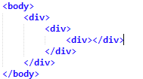

**Case 1:**Below CSS styling has all three div elements of type position: static,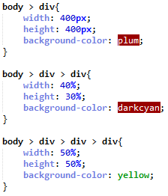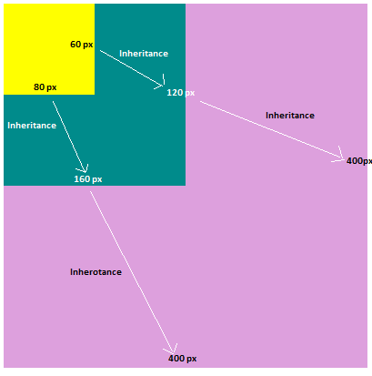

**Case 2:**

Below CSS styling has only inner most div element of type position: relative,

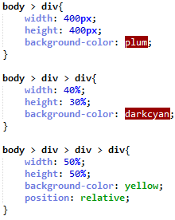

No difference in the behavior

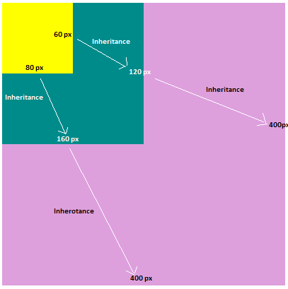

**Case 3:**

Below CSS styling has,

* Inner most div element of type position: absolute,
* Outer most div element of type position: relative.

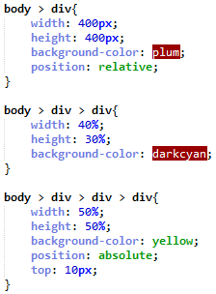

Behavior changes in inner most element. Dimensions are inherited from outer most div element.

